iCell Journal Viewer User guide

# Introduction

iCell Journal viewer is an application uses to search, filter and review (and print if required) transactions based upon many search criteria.

There are basically three steps to using the journal viewer:

* Search the database based on rough search parameters
* Within the search result, filter based on more detailed attributes
* Select one or more of the filtered transactions and review/print the transaction or the combined transaction.

Setting up of iCell Journal Viewer requires you to set up database access to the required database via iConfigure specifically for iCell Journal Viewer.

First, this user guide will give you a brief run down on how transactions work in iCell to allow you to better understand the formulation of search queries and filters, then it will summarise the use of iCell Journal Viewer.

# iCell Transactions Overview

Transactions within iCell are hierarchical in nature. The overall transaction contains accounts, and transaction parts. Each transaction part contains many transaction details. The details are what contain the individual product and/or payments within the transaction.

Each transaction has a transaction class, which might be tax invoice, or receipt or manifest (for stock transfers) to name a few. It also contains the start and end times for the transaction.

The part can be effectively treated as if it were the transaction for the purposes of the searching, but it contains things like the location and till. It also contains the table number.

The detail is where all the hard work of the transaction is done. It contains a transaction detail type. Some of these are Sale or Return (for product), Refund or Receipt (for money), Stock, Sundry and many others. The detail also contains information about the product, the product grouping and pricing/behaviours for a sale/return and the payment information, payment method and amount for refund/receipt items. It also contains detailed information about the cashier that performed that particular actions.

This rough outline is important in that the journal viewer searches through each of these hierarchical parts but ultimately has to choose if a transaction is viewed or not. Sometimes this may lead to apparent contradictions, but in context of the hierarchical nature of the transaction – the search results are correct. In essence, be careful when combining searches or filters across attributes at different levels of the hierarchy.

# Database Searching

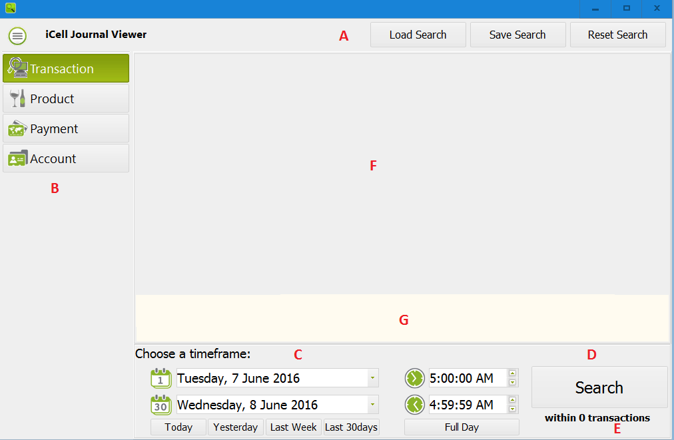

The main form of the journal viewer consists of several shared parts and a couple of parts that are unique one of the four ways of doing your initial search.

1. Header along with search saving and loading functions. You can save an existing search to load back in later via these functions. Reset search clears the form to defaults.
2. Select one of the four ways of doing your initial search. Overall transaction search, searching on product, searching on payments or searching on accounts/customer.
3. Chose a date range, using either the calendar and clock editing functions you can set a range of date and time for the search. The narrower the range the better. Use the four predefined date ranges (e.g. Yesterday) for quick searches of that period. Full Day sets the time to a full trading day (to 5AM).
4. The search button, this will perform the search against the database and open up the filter form for more detailed narrowing down of your transactions.
5. Shows how many transactions total occur within the timeframe. You want to ensure this number isn’t too big. Keeping this under 5000 or so will make your filtering a lot easier.
6. The method specific search options, depending on which method (see B) you have chosen different options will appear here.
7. A short description of the search you are doing with additional hints if appropriate.

The first search is the transaction search:

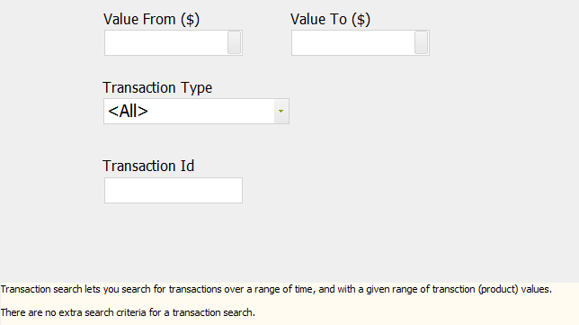

* **Value From/Value To**: This allows you to specify a range of the total product value for the transaction (blank means ignore). To select a maximum, leave the ‘from’ blank and enter a ‘to’ value. To enter a minimum, enter a value in the ‘from’ value and leave the ‘to’ value blank. To enter a range, fill in both values. To include all values – leave both values blank.
* **Transaction Type**: This allows you to choose the type (class) of transaction from such types:   
  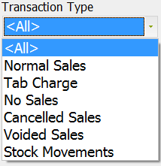
* **Transaction Id**: If you leave the other fields blank, then you can find a specific transaction by filling in just the transaction Id.

The next search is the product search. Remember, that this will show you ALL transactions that match the criteria set.

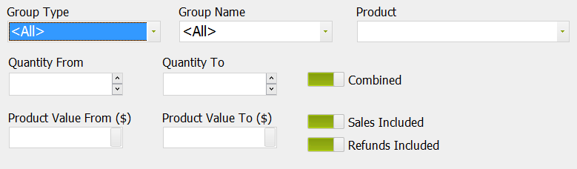

* **Group Type/Group Name/Product** : These dropdowns allow you to specify varying levels of searching for product. If you specify just the Group Type and Name then transactions with any product in that group (e.g. Group Type “Group” and Group Name “BEVERAGE”). In the context of the search. If you wish, you can select a product or type in a product id to search for specific products.  
  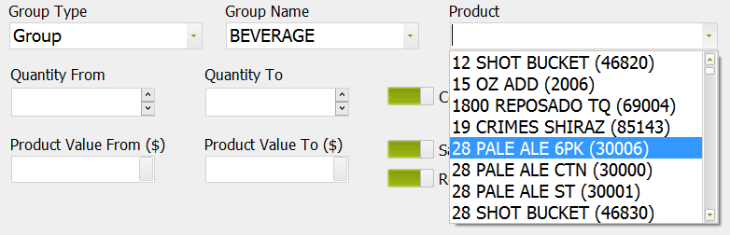
* **Quantity From/Quantity To**: You can specify a range of quantities of product (e.g. 10-20) to return transactions with that quantity of product. As before, search for minimum by setting only the ‘from’ and maximum by setting only the ‘to’ and a range by setting both. Note that the ‘combined’ check box if selected means the quantity will be transaction wide total, if not checked the quantity will be in one detail (i.e. one sale within the transaction). Choose Sales/Refunds to include/exclude as appropriate.
* **Product Value from/Product Value To**: These operate exactly as quantity, but specify a search based on the final sell price of the product.
* **Combined**: Select this if you wish the search to total up the quantities/values for the entire transaction. Deselect it if you wish to search for line item quantities/values.
* **Sales/Refunds Included**: These two check boxes allow you to search only on sales, only on refunds (i.e. returns) or on both.

The payment search allows searching based on payment type and payment value.

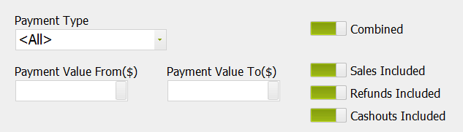

* **Payment Type**: If you want to search for a particular payment type (e.g. EFTPOS) select it here, otherwise leave it set to <All>  
  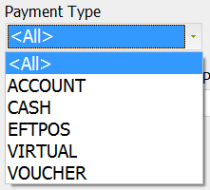
* **Payment Value From/To**: Search for a range of payment amounts, as previously set ‘from’ only for an ‘at least’ search; set ‘to’ only for an ‘at most’ search and both for a range.
* **Combined**: Select this if you wish the search to total up the values for the entire transaction. Deselect it if you wish to search for line item values.
* **Sales/Refunds Included**: These two check boxes allow you to search only on sales (i.e. receipts), only on refunds or on both.
* **Cashouts Included**: With this option checked, cashout values will be included in amounts. This can be misleading if you are searching for a $100 payment, if $60 of it was cashout. So be careful with the setting here.

The final search option is account search and allows for searching based on account/customer and payment vendor (e.g. COUGAR/FINCHCORP etc).

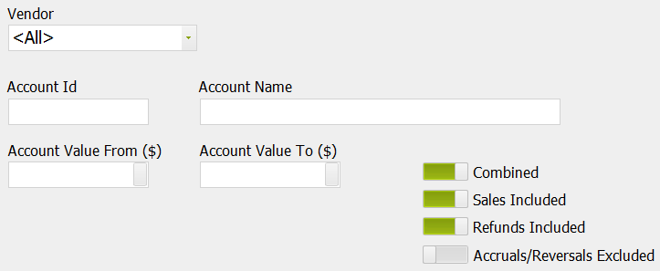

* **Vendor** : allows you to select a payment vendor to search for. A payment vendor is a payment interface (e.g. FINCHCORP, COUGAR, ARISTROCRAT etc) that supports accounts and/or customers.
* **Account Id/Name**: You can type in either an account id, or a part or full name to search for transactions that include that customer.
* **Account Value From/To**: Search for a range of payment (or other amounts) related to that account, as previously set ‘from’ only for an ‘at least’ search; set ‘to’ only for an ‘at most’ search and both for a range.
* **Combined**: Select this if you wish the search to total up the values for the entire transaction. Deselect it if you wish to search for line item values.
* **Sales/Refunds Included**: These two check boxes allow you to search only on sales (i.e. receipts), only on refunds or on both.
* **Accruals/Reversals**: This checkbox allows you to include searches for accruals and reversals (un-accruals) to/from the account. Note that accruals and reversals don’t necessarily reflect real currency values, and also exchange rates on the interface may alter the value of these accruals in the external system. This search may not take that into account when specifying ranges of values.

# Results Filtering

Once you have searched the database, a new form will appear over the main form. The new form allows you to filter (in memory) the results that have returned from the database. This searching is quite detailed and in some cases complex. The new form consists of four sections:

1. The Filters Section
2. The Transaction List Section
3. The Transaction Preview Section
4. Commands (Print/Preview and hide filters).

Generally speaking, you will make changes on the filters area, select suitable transactions via the transaction list, preview the output in the preview area and optionally output to PDF for printing or saving of the report.

The filters section consists of four main areas just like the main search form did, they are:

* Transaction Filtering
* Product Filtering
* Payment Filtering
* Account Filtering

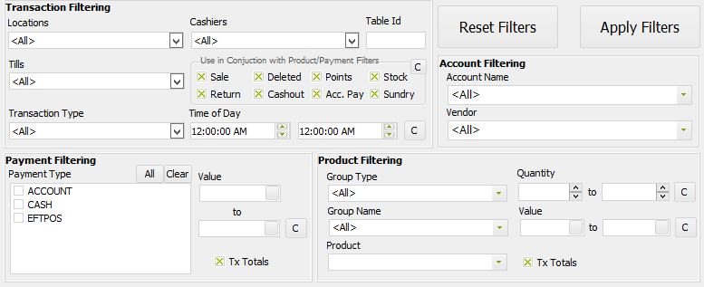

Remember, that some of these filter options will filter detail and others will filter transaction wide. Most of the filtering options are the same as those described on the main search pages. The following notes will describe the differences and clarifications:

* **Reset/Apply Filters**: Resets the filters to defaults (everything) or applies the current filters (narrowing the result set).  
  
* **Tx Totals**: The main search page referred to ‘Combined’ which is effectively the same as the Tx totals check box. If checked it will for each of the filter sections use transaction totals, and if not use line item totals.
* **Account Filtering**: Is identical to the main account search page, except that only the accounts and vendors used anywhere within the current result set are shown in the two drop downs.
* : This button resets the from/to associated with it to clear (that is all).
* **Locations/Tills/Cashiers Filtering**: Allows you to filter out transactions which had activity at given locations and/or tills. The clear button on these drop downs sets the value to ‘<All>’.  
  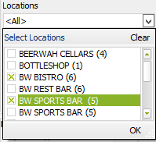 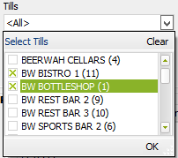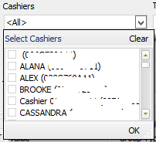
* **Transaction Type**: Is the same as the main transaction search page, except it allows for multiple selections: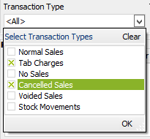
* **Detail Type**: This is new, and allows specific filtering of detail types. It is primarily used to exclude certain results which otherwise may be returned via other filters. Selecting all is the default.  
  
* **Payment Type:** Like the payment type search, however you can specify multiple types to include each of them:  
  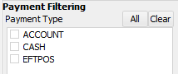
* **Time of Day**: This is a subset of the full date range on the main search, if you wish to specify date ranges please use the search option on the main form. To filter on time ranges for activity set the start/end times.  
  
* **Table Id**: Filter by table id by entering a value here:  
  

Once you are happy with the filtering, you press Apply Filters. Then you can preview/select transactions until you are happy with the result.

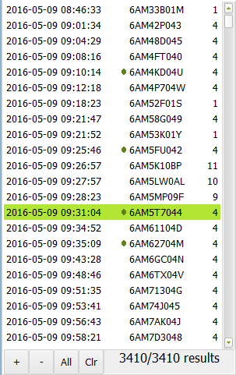The transaction list has a number of functions:

Selecting one transaction will preview that transaction.

The footer shows the number of transactions filtered followed by the total number of transactions returned by the initial search.

Pressing the + button will add the transaction to a merged transaction which is shown in the preview.

Pressing the – button will remove the transaction from the merged transaction.

If only one transaction is selected, the preview will show it in single transaction mode.

If multiple transactions are selected (via +/- buttons) then it will show it as a merged transaction.

The All button will select all transactions for the merged transaction.

The Clr button will reset the view to single transaction preview.

The preview pane shows the transaction or merged transaction:

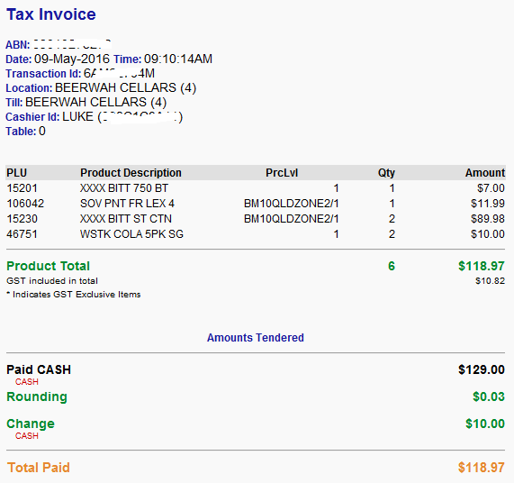

Once you are content with the preview, you can press either:

 to produce a report showing each selected transaction separately.

OR

 to produce a report showing a single merged transaction. This option is only available if multiple transactions are selected.

When you press either of these buttons, a PDF file is created and opened in your default windows PDF viewer application. If you don’t have one selected, then Windows may ask you to install and/or select one.

If you wish to have more space to preview the list and transaction preview – then press the  button to temporarily hide the filters section freeing up more screen space. Press the button again to re-enable the filter section.